Unit: II Writing Skills
Topic: Writing reports based on graphs/data
(Note: In the examination, you will be asked to write a report in 150 words on the given graph or data. )

What is being tested here is your ability to:
- objectively describe some graphic information
- compare and contrast
- report on an impersonal topic without the use of opinion
- use the language of graph description
- You are not asked to give your opinion.

Sample task

Write a report for a university lecturer describing the information in the graph below.
Write at least 150 words.
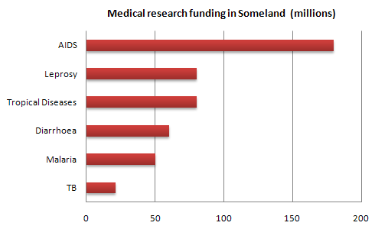
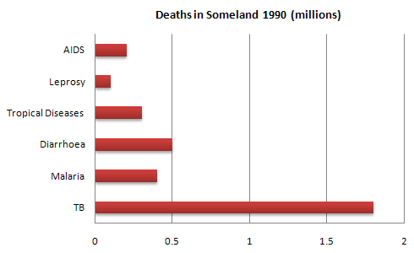

Guidelines for a good answer:

Does the report have a suitable structure?
- Does it have an introduction, body and conclusion?
- Does it include connective words to make the writing cohesive within sentences and paragraphs?

Does the report use suitable grammar and vocabulary?
- Does it include a variety of sentence structures?
- Does it include a range of appropriate vocabulary?

Does the report meet the requirements of the task?
- Does it meet the word limit requirements?
- Does it describe the whole graph adequately?
- Does it focus on the important trends presented in the graphic information?

Sample answer:

The graphs compare the number of deaths caused by six diseases in Someland in 1990 with the amount of research funding allocated to each of those diseases. It can be clearly seen that the amount of research funding in many cases did not correlate with the seriousness of the disease in terms of numbers of deaths.
In 1990 there were around 0.2 million deaths from AIDS, 0.1 million deaths from leprosy, 0.3 million deaths from tropical diseases, 0.5 million deaths from diarrhoea, 0.4 million deaths from malaria and 1.8 million deaths from TB. These figures can be contrasted with the amount of funding allocated for each disease. In 1990 AIDS received 180 million dollars in research funding, leprosy 80 million dollars in research funding, tropical diseases 79 million dollars in research funding, diarrhoea 60 million dollars in research funding, malaria 50 million dollars and TB 20 million dollars in research funding.
In conclusion it is clear that funding allocation for disease research in Someland is not wholly determined by the number of deaths for which each disease is responsible in a given year.

Graph II:
Look at the following graph and read the description.
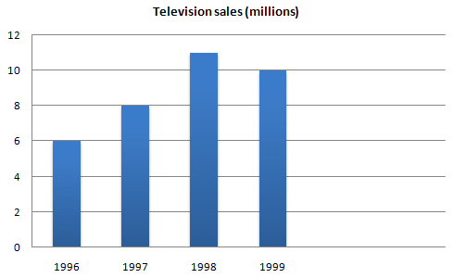
In this graph of Electro Inc’s television sales between 1996 and 1999, we can see that purchases of televisions went up in 1996 and continued to rise steadily until 1998 when they dropped slightly.
In some cases, however, it will not be appropriate to describe the bar graphs in terms of time and different language will need to be used. For example, in the following graph we could not say:
In 1990 there was a rise in holiday makers from Indonesia.
because the word ‘rise’ implies that the graph also shows a lower number of holiday makers at an earlier time, which in fact it doesn’t.
Task: Find out at least two similar graphs and related report writing from books or internet and write them in your journal along with the above writing.

